**Documentation for the Ventilo Live Plotting Application**

1. Physical Setup
   1. You will first need to attach the phone connector to the RoIP port on the Wave Relay radio.
   2. You will then need to attach the LAN adapter to the DATA port on the Wave Relay radio.
   3. Connect the LAN cable from the radio’s adapter to the LAN port in the computer.
2. Software Configurations
   1. Go to the Network and Internet Section in the Control Panel

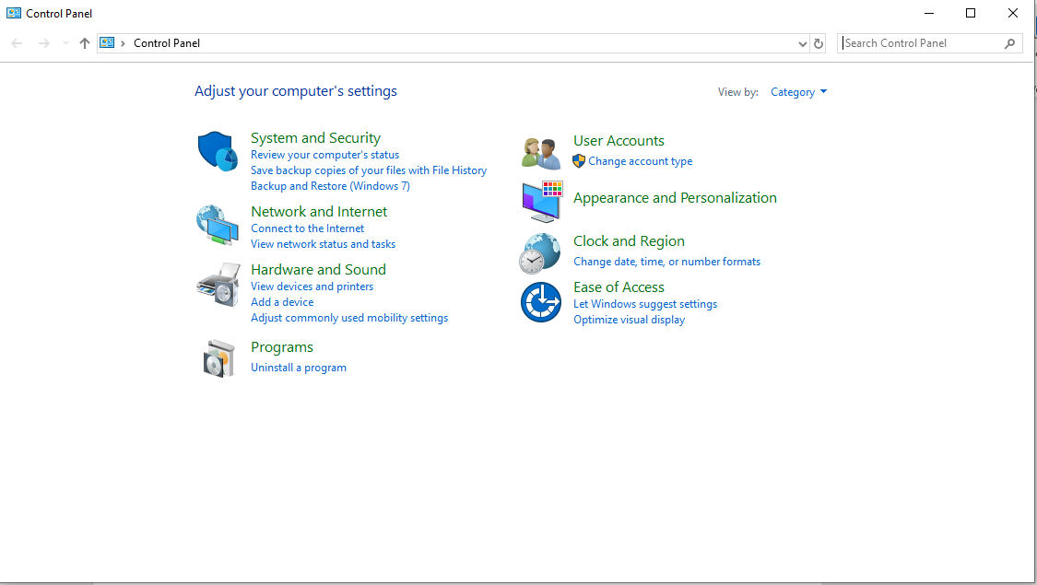

* 1. In the Network and Internet Section, Search for ***Network Connections*** and click on ***View Network Connections***.

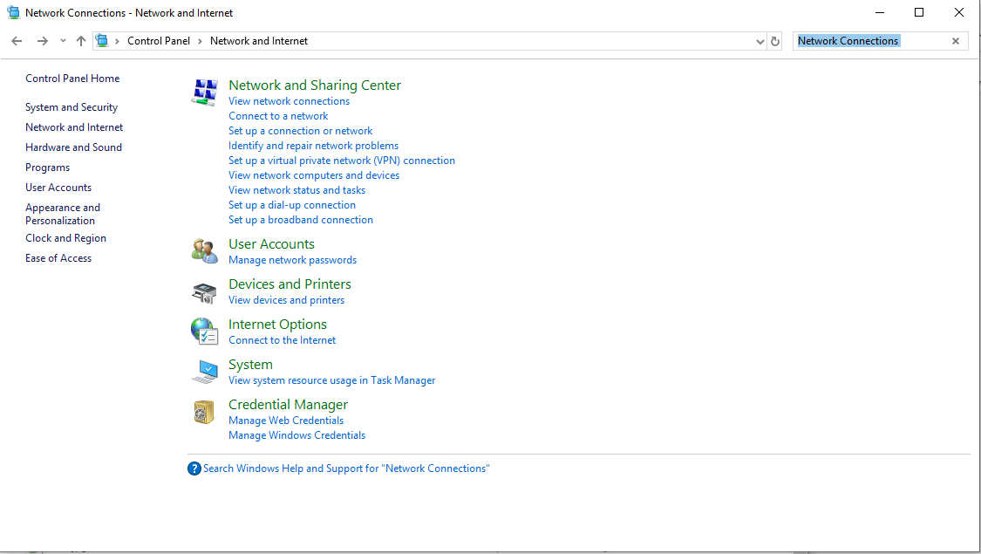

* 1. Right Click on the Ethernet Connection and click ***Properties***. You will then need to click on the ***Internet Protocol Version 4 (TCP/IPv4)*** and click on properties.

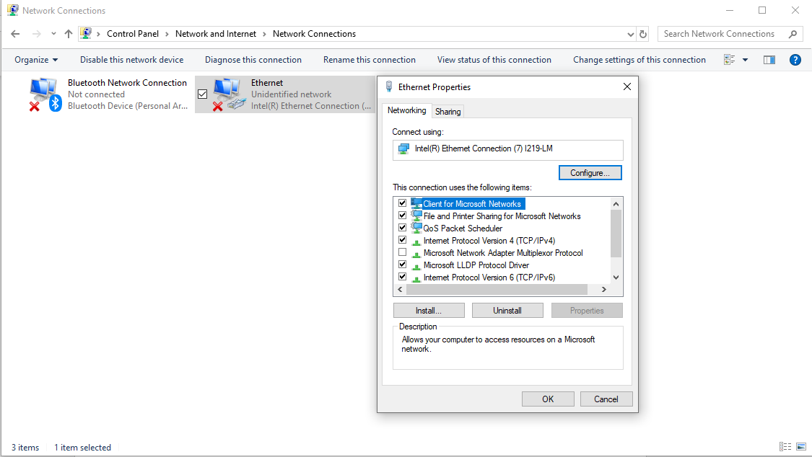

* 1. You will then need to configure the IP address and Subnet Mask as shown below: (This is configured just for radio Number 4)

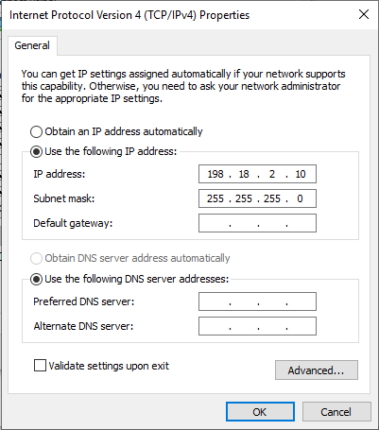

* 1. Once done, you would need to check the connection of the radio and the computer by going into the Wave website. (Not quite sure yet)
  2. You will then need to enter the ***Windows Command Prompt*** to ping the phone that is connected to the Radio. (***ping <Phone Static IP>***)

* ***<Phone Static IP>*** can be found in the wave relay application settings under ***Network Utils > Static IP***

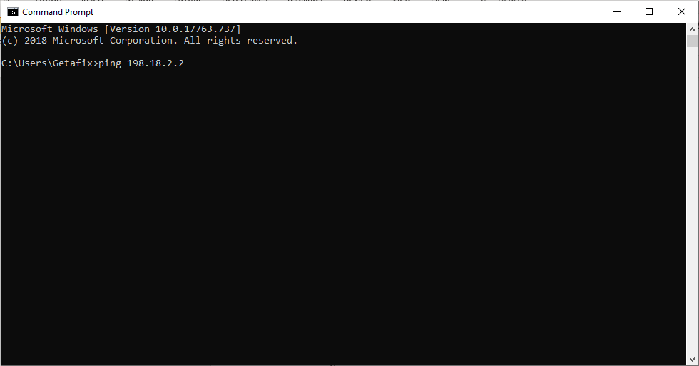

1. Python Configurations
   1. For the live plotting:
      1. Go to the ***WorkingDataPlotter.py*** and start the script by typing the following line:

connection(ipaddress, port, csvName, topicfilter = None, groundtruthCSV = None)

* **Ipaddress** – IP Address of the phone that you want to connect to
* **Port** – Port number that the phones are linked to
* **csvName** – Name of the CSV that you want to save the plot into (For Historical Plotting)
* **topicfilter** – Use this if you want to listen to specific things in the Pub-Sub Network
* **groundtruthCSV** – Use this is you want to include a Ground Truth Plot.
  1. For the Historical Plotting:
     1. Go to the ***HistoricalPlotter.py*** and start the script by typing the following line:

plotHistorical(csvName)

* **csvName** – Name of the csv file that was generated from the live plotting.

*for the Historical Plotting, if you encounter an error that has something to do with x-coords, go into the csv file and check if there are duplicated x-coords, y-coords, z-coords.

*for the Live Plotting, if your graph says not responding or just hangs, you would need to check if the phone is inputting in any data into the graph.

*for the Live Plotting, if you see that the graph suddenly rests, don’t worry. That is a feature that has been implemented to prevent the python file from crashing. You can view the whole plot in the historical plot.